CHAPTER SIX- Let’s Talk Money

“If I make enough money, the expenses handle themselves.”
“Business is easy, I just make more than I spend.”
“My accountant handles the books, I make sure the customers are happy.”
Any of these statements are fine to make if you are not the business owner or manager. If you do find yourself in one of those positions, growth requires that you build a business model that will scale and thrive. That business model is how your business brings in money and how it uses that money. Simply trying to outrun expenses or, worse yet, ignoring them is proven to lead to disaster.
This doesn’t mean you have to become a CPA or get a degree or certification in financial planning. Understanding the money aspects of your business model is different from being an accountant. For our purposes, financial accounting reflects what your accountant and bookkeeper (if you have them) do for you. Managerial accounting is how you understand your financial position to make business decisions.
Let’s break these down a little further. Financial accounting is specific, down to the decimal, reflective on the past, and is most commonly used when you fill out your tax forms. Managerial accounting is more general, used to plan and forecast, is strategic and forward-facing, and is used as a tool to grow your business. While both types use data accumulated in the past, only one is reasonable for busy business owners and managers to use regularly. This chapter is about managerial accounting; trust your CPA to handle the decimal dust, build your tax plan, and keep you legal.

Understanding the Data Our Business Provides

There are a handful of basic tools we need to use to organize, understand, and strategize using our business data. The most powerful of these is the Profit and Loss statement- a simple, often overlooked (by managers) sheet that tells us exactly how our business model works in dollars.
The profit and loss statement shows money out, money in, and what you’ve made over a period of time. Like any financial tool, it is a picture of the past; but like weather models that use historical data and observations to forecast hurricanes, floods, tornadoes, and beautiful sunny days, this picture can be shaped to understand your future trends. Before we get into how to use the P&L as a predictor, we have to understand how it is structured.

Anatomy of a P&L Statement

The profit and loss statement has a straightforward structure perfect for understanding the financial flow of a business. For this chapter, we’ll be using a fictional P&L from Two Brothers Coffee Shop, a fictional firm. This lesson is even more valuable if you have a copy of your own P&L open on your computer or in hand.
Let’s start by looking at the P&L, using the example section at the start of the next page. Please note that not all P&Ls will be structured identically- different firms count different expenses with different labels.However, this is a good general example and a great place to start.
At the top of the statement is the data period (in this example, year) and gross sales- or revenue- of the firm. Typically following are the immediate costs of goods sold- raw materials, inventory, cost of services, or other costs directly associated with the inputs required to get an item on the shelf. These two factors are the key elements that go into figuring gross profit- the profit a company makes after deducting the costs associated with making and selling its product or providing its service. Gross profit is reflected as the third item down on this example and is figured with the formula Gross Profit = Revenue-Cost of Goods Sold (COGS).
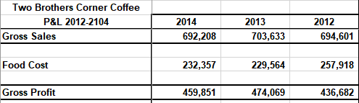
As we continue down the P&L, we begin to see the additional fixed and variable costs associated with operating the business, as seen below.
Fixed costs are costs that remain constant no matter the amount of goods or services sold. Typical fixed costs include rents, salaries, and insurance. Fixed costs are often similar month-over-month, but that is not a requirement; any cost that does not track with sales is considered a fixed cost. In the example above, nearly all of the costs are fixed costs.
Variable costs are costs that vary with the level of output (or sales). Direct materials, piece-rate (often contracted) labor, production supplies, billable wages, credit card fees, sales taxes, and commissions are examples of variable costs.
For managerial accounting purposes, we sometimes class some costs as other costs. These are costs that show up in the books but have little ‘real’ value to us as managers outside of tax purposes. A good rule of thumb is that if these other costs are less than one percent of sales when combined, they can be lumped into one category. This is because they are so little of your expenses (one penny on every dollar sold) that they are overshadowed by larger expenses that need more management focus.
Take some time right now to classify the costs that are showing up in your P&L.
At the end of the P&L sheet is your expense total and last, your net profit or loss (also called income). Net profit (income) is figured by subtracting total expenses from gross profit: net profit = gross profit – total expenses. You can see this reflected in the P&L example below.
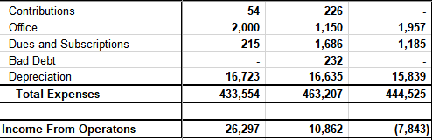
You can see that in 2012 (on the far right), Two Brothers operated at a loss, but managed to improve their lot and bring in a profit in the following two years.
There are a couple other general notes for how we set up P&Ls for managers. Often, accountants set up a P&L running left to right by year- the furthest back year starts on the left, and more recent years are to the right. As we manage, we prefer the opposite- recent years on the left, past years on the right. This layout allows us to always look at recent data first. Second, remember that your P&L categories, and what you classify as fixed and variable expenses (which will be discussed in deeper detail further along in the chapter), will likely vary depending on your business. In fact, once we have checked that numbers are in order, our team’s managers often totally remove costs such as depreciation from our managerial P&L, as they represent tax implications, not management costs. Last, note that we round everything to the nearest dollar. Like we said earlier, we’re managers, not tax accountants. There’s no need to baffle ourselves with detail.
Now that we’ve done a general walkthrough of how the P&L appears, it is time to learn how to use it to manage the business. Again, this lesson is much more valuable if you have a copy of your own P&L open in Excel.

Using the P&L

While it’s great to see your numbers, and it’s enlightening to classify and play around in a P&L, most businesses want to know how their numbers relate to their future or how they can help the business plan. Frequently managers are taught about financial ratios (quick ratio, debt-to-equity ratio, etc.) which can tell a story, but only with context. Without context, or without understanding what is good or bad for your industry, ratios can have little worth as management tools. That’s not to say these aren’t valuable in some cases- when pursuing a loan with a bank, for instance, it’s important to understand what the banker means when he discusses your ability to pay off your debts with the business.
We like to teach the P&L in a different light.To simplify, a P&L tells us three things- how much money is coming in, how your company uses that money to make more money, and what is left over. While we cannot always control how many sales we make or how rapidly the payments come in, we have much more control over those funds that go out. This is where the P&L shines as a management tool- after all, every dollar saved is a dollar added to the bottom line.
Think back to your fixed and variable costs, which you should have marked up on your own P&L sheet (remember, fixed costs are not tied to sales; variable costs are tied directly to sales). It’s important to classify each cost because we must manage both types- and they are key tools in understanding our business model. Our favorite way to understand costs over time is to break each down as a percentage of sales with the formula % of sales = expense / gross sales. You can see this broken down in our example P&L below.
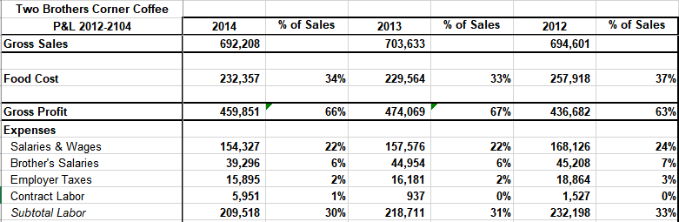
Breaking down costs this way allows us to begin understanding how much of each dollar goes to each type of cost and puts into a picture the way variable costs track with sales. As managers handle everything thrown at them throughout a given day, sitting down with a quick breakdown of numbers that tells you 34 cents of every dollar earned goes to food costs (as an example) is incredibly valuable. Along with that, percentages help put context around your business and help you begin to plan and adjust your business model.
Take some time to find each costs’ percentage of sales using the formula % of sales = expense / revenue.
Knowing these percentages, though, is only part of the game. Just like with ratios, how do you know that 34% of sales going to food costs is good without context? How do you know if your labor costs align with the industry or your area? How do you spot expenses needing improvement/reduction? Like many things in your business, it’s going to rely on your management knowledge - but there are some things that can help guide your understanding and empower you to make decisions.

Benchmarking

Benchmarking, or comparing your company’s performance to other firms or best practices in your industry (or region), is a valuable way to understand whether your costs are in line. Industry associations, chambers of commerce, or internet resources are all places where valuable benchmarking data- often broken down in a percentage of sales format- can be found. These resources are best as they combine data from a number of firms and figure averages based on that data. Surprisingly, asking other owners in similar industries or regions can also work
Asking a friendly competitor about costs as a percentage of sales keeps exact numbers from being shown, and allows other owners to maintain a measure of secrecy with their numbers while also being able to benefit an industry partner. Seeing where your costs, as a percentage of sales, fall with respect to other firms can help you pinpoint where to make adjustments or at least address specific cost areas with confidence. Keep in mind, your goal is not to be exactly like everyone else. You may choose to spend 3 more percent on labor because you want better than average or 5% more on food costs because farm-to-table is not as cheap as big-box wholesaler produce.
Take some time to look up benchmark data online for your firm or ask a peer what their costs as a percentage of sales are.

Percentage of Sales as a Business Model

Percentage of sales data can also help you understand what your business model is, and what you need to prioritize as a firm. Before we continue, we have included the complete Two Brothers example P&L as well as additional tools in a spreadsheet with this chapter - all following shots are from the second tab (‘simulations’) of this sheet. Before we continue, we’ve included the complete Two Brothers example P&L as well as additional tools in a spreadsheet with this chapter- all following shots are from the second tab (‘simulations’) of this sheet.
We’ve classified costs in the sheet based on our experience and insight; you may classify yours differently. For now, let’s look at the total percentage of costs breakdown for Two Brothers (the percentages are rounded for ease) over the last three years combined. This will tell us a lot about their business model and what they need to strategically prioritize in their firm.
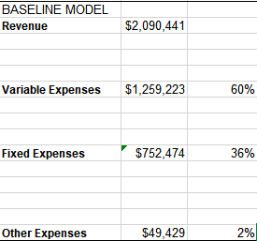
You’ll see that the majority of costs for Two Brothers are variable, or track directly with sales. Whether this 60% is in line with industry or not we don’t know, but we can use this current picture to make decisions. Knowing that variable costs are high, seeing the lower number of fixed costs, and knowing that variable costs track directly with sales, what kind of decisions on cost cutting, sales efforts, pricing, or marketing would you make?
There are several options. We can always work to control variable costs through techniques like managing waste, negotiating with suppliers, and training employees to be more productive. These may be more medium-term efforts. We can take steps to reduce the volume of sales slightly while increasing margins by increasing costs. We could also accept that that 60% is what it is and keep on with what we’re doing. We could even turn to fixed costs and work on those by renegotiating rent, insurance, or salaries, though those are often harder to manage and frequently involve long turns, hard efforts, and negotiations.
With this business model, and this subset of data, what kinds of things would you do to improve profits?
Imagine now a model that is flipped. Let’s say fixed costs are 60% of sales, with variable and other making up the rest. How does that change things? Since fixed costs are usually less negotiable and tougher to manage, maybe we ramp up marketing efforts and attempt to drive more sales. Since fixed costs stay the same no matter what, every sale made decreases the cost per unit sold.
Included in our attached Excel file is a simulation tool based on the Two Brothers example P&L. This tool can be tweaked and tailored to your business, and is best used in a hands-on, practical manner.
Break out your costs similar to the sheet above, and fill in the simulation tool. What does this tell you about your business model? What kind of situations help you make the profits you want?
The P&L and the tools provided alone don’t tell the entire picture, but are valuable assets for making strategic decisions for your business. Play around with the simulators, fill in your numbers, and start to understand how your business breaks down by costs. You may find yourself enlightened.
Before we move onto Cash Flow section of this chapter, we have some quick tips and things to remember for P&L management based on our experience with small businesses, banks, and financial resources:
  - We want to manage our P&L because we want to grow our business and cannot without knowing how the money machine that is our business works.
  - By managing our P&L, we can talk to bankers, financial resources, buyers, suppliers, and more intelligently and with confidence because we know our business.
  - Tactically, it is important for owners to pay themselves a salary, or build a fair salary into the financial plan; businesses are not profitable in the eyes of a banker if the owner isn’t taking a reasonable salary no matter how good the business may look on paper.
  - Understanding how much of each dollar sold goes to which category of costs (fixed, variable, other) helps us prioritize strategies that increase sales, slow sales, or other goals with the objective of increasing profitability. It also helps us know whether we should do things like prioritize retail or wholesale and understand if certain lines of business are profitable or should be cut.
  - Again, P&L is not the whole picture, but provides the numbers-backed skeleton for our business; we may have products or efforts that aren’t profitable themselves but bring people in the door (where they inevitably purchase something else)…understand this, and make smart, holistic decisions.

Cash Flow

Now that we know our business model makes money, is that money available when we need it?
In a small business, cash-flow is everything. A business can make an incredible amount of money, but if it comes in after the expenses are already due, the company is in trouble. This is the leading cause of small businesses going bankrupt. And as a business grows, keeping the cash flowing effectively to pay bills becomes more and more complex.
Few businesses have a cash flow that flows smoothly. Most have cash that flows in large lumps. Imagine a construction company that gets paid when they are done framing the house or a caterer that is paid after a 200-person event. This type of cash flow is lumpy, it doesn’t come in every Friday yet expenses are being incurred daily to meet the production plan/service agreement. As managers we have to understand our outflow of cash and when we can expect to replenish it and make a profit.
Real life example: a bakery in another area recently purchased a new vehicle; the purchaser signed a form for a $2,000 down payment and was banking on receiving a large due invoice the day of purchase; receipt didn’t happen, and the business had to dip deep into a dangerous cash level to make the down payment. The company depended on an outside person to make a payment. The company got into a dangerous cash position, even for just a couple of days.
Before we dig into this concept, keep in mind cash flow is the hardest thing any business has to manage. Once we know our business model, our P&L, produces profit, we have to manage the expenses and income to ensure that income is realized in time to pay our bills. If it isn’t, we have to pay for money, i.e. take a loan or use credit, then we add to our expenses as we buy time until our income comes in…costing us profit. To manage this flow of cash, most firms and managers use a Cash Flow Statement.

Cash Flow Statement

A cash flow statement begins with the amount of cash you have on hand at the beginning of a period (cash in the bank, petty cash, operating cash in the till/safe, etc.). That amount is added to by all of the cash that comes it, not the sales made, but the actual income collected during the period. The period can be a day, a week, a month, or a year. It is recommended that small businesses run their cash flow on a weekly basis. Below is an example cash flow statement.
 | June | July | August | September
Cash Received
Beginning Cash | $1,000 | $1,500 | $3,800 | $550
Sales Collected | $4,500 | $6,000 | $2,200 | $5,000
Receivables Collected | $500 | $750 | $0 | $1,000
Other Cash Income | $0 | $250 | $0 | $450
Total Cash On Hand | $6,000 | $8,500 | $6,000 | $7,000
Cash Spent
Salaries/Wages | $1,800 | $1,800 | $2,400 | $2,400
Cost of Goods | $800 | $1,000 | $1,200 | $1,000
Rent/Mortgage | $1,200 | $1,200 | $1,200 | $1,200
Insurance | $200 | $200 | $200 | $200
Utilities | $400 | $400 | $400 | $400
Operating Supplies | $100 | $100 | $50 | $150
Total Cash Spent | $4,500 | $4,700 | $5,450 | $5,350
End of Period Cash | $1,500 | $3,800 | $550 | $1,650

In this example, the company sees in increase in sales in July and uses that to hire another employee (see Salaries in August increase) and an increase in their cost of goods as they forecast more sales. However, in August, sales do not increase, in fact they decrease, leaving the company with less than a thousand dollars in cash at the end of the month. If this owner would have looked over their historical sales, they would have remembered that their customer base goes on family vacations in August and their sales always dip. That may have helped them decide to hold off on hiring their new employee until after the dip and would have most likely informed them that there is no need to buy the additional inventory (cost of goods).
Take some time right now to build your Cash Flow Statement.
Before we go forward, use your bookkeeping system to pull a cash flow statement in excel. Unless your bookkeeping system is tied directly to your bank account, the Cash Flow Statement will not be accurate (because it cannot see the actual cash you have on hand). However, we can take the spreadsheet that is provided and updated it with your bank and on-hand cash information to help make it accurate. Follow these steps:
- Export a cash flow report for the last three months from your bookkeeping system
  - Pulling it for the last year or two is better, but requires;
- Pulling your bank statements for the same time period so that you can enter the actual starting and ending amounts
  - Note – there will likely be discrepancies. They exist most likely because there is spend that is not caught in your bookkeeping system. It should be! – identify what it is and update your bookkeeping system to account for that spend in the future. That way it will be easy to reconcile and manage in the future and you do not have any holes money can fall through in your management accounting.
- Update the cash flow statement with the beginning amounts and ensure all incomes and expenses are accounted for so that the remaining cash matches your bank statement
- These three short steps take some companies days to do at first, but the next time it will only take 5 minutes to update and provide you a clear view of where your cash comes from and goes to.
Now that we have your cash flow in hand, how do we begin understanding that cash flow and, better yet, predicting it in the future?
Before we dig too deep, keep in mind that the cash flow statement is not the P&L, the numbers here are real dollars entering and leaving your cash drawer and bank account. For many small businesses, their business flows in cash (whether a cash, check, debit/credit card payment), it is received in 24-36 hours of sale). Some firms extend credit to their buyers allowing for 30+ days to pay off the purchase. This decision to extend credit and delay income has to be factored into your cash flow plan. A point to note here, if you are simply managing cash flow by what your bookkeeping system says, you are only tracking the past. To be an effective manager, you need to predict the future with increasing accuracy.

Predicting Cash Flows

This requires tracking your expenses and incomes based on when they should be received based on the contract or sales agreement. For a retail shop, this is usually all handled at the point of sale when the good is traded for payment. Even then though, if they pay in credit card or online payment, there could be a day or two delay in you receiving the funds. For non-POS closing of the deal, there is some delay in payment. It may be the time it takes to write and mail a check or a NET-30 term agreement whereby your customer will not cut the check until next month. You need to expect and plan for this.
There are lots of fancy software packages and tools that help you predict cash flows, but they all pale in comparison with a simple spreadsheet. The hard part about forecasting is understanding, not just knowing, the past. If you can pull your past two to three years of monthly income and expense and enter it into the spreadsheet, you will be able to see the pattern of your market. Many companies see big up swings in income during back-to-school season, or Christmas, or Valentine’s day. For others it comes with bad weather or regional sporting events. Whatever drives the spike in sales, you need to understand and predict it (as well as staff, market, and plan inventory for it, but those are for other chapters). Using a simple spreadsheet allows you to watch the pattern over time and better predict that pattern going forward. On the next page, let us look at the expanded cash flow statement from above.
NOTE: Don’t be intimidated by the next page - Using bar charts or line graphs within the spreadsheet tool you are using (or by hand) will help see the pattern even if you do not consider yourself a “numbers person.”

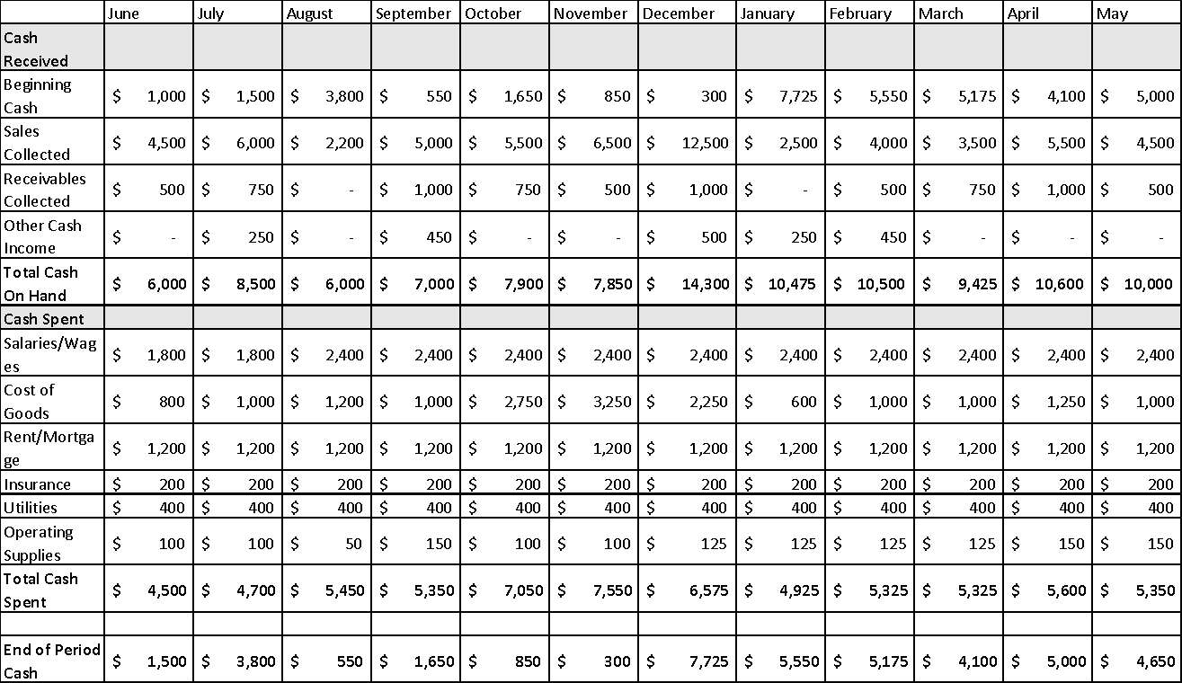
A simple cash flow statement:

Those of us with a preference for numbers can look at the table on the previous page and see the peaks and valleys easily. For the rest of us, it is easier to see a line or a bar graph. Try for yourself with the images below. They are graphs of the data in the table above.
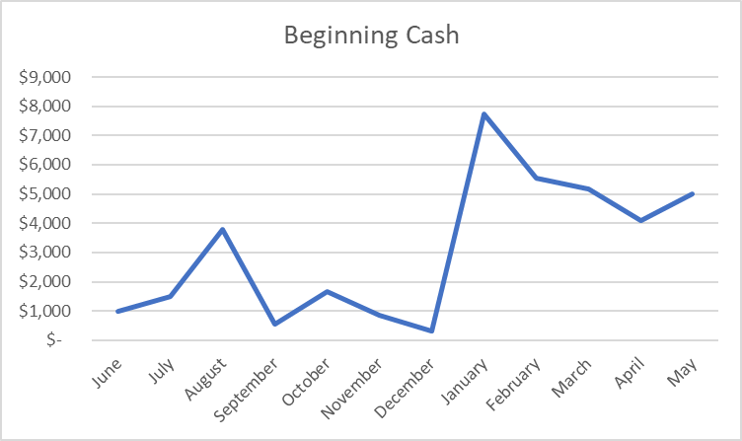
In the Beginning Cash graph (above), it is easy to see that after a large sales in the Christmas Season, the company is flush with cash on January 1. Similarly, starting in October, much of the company cash is invested in inventory and labor, taking cash reserves to a very low level. As an example, this puts the company into a risky position should they have a slow Christmas Season one year.
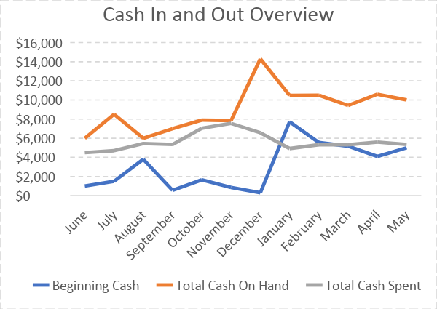
In the Cash In and Out Overview (above), we can see that for most of the year the Total Cash Spent in a month is higher than the beginning cash for that month. That tells us that we are running a very lean businesses and require steady monthly sales to stay afloat. It is an indicator that we should work to reduce our expenses and continually save into our cash reserves to buffer for a slow period. Imagine for any month if the sales were cut in half – the company would struggle to afford its monthly expenses. Reducing the expenses and saving reserves would help especially if that slump in sales was for an entire quarter instead of only one month.
If the line graph doesn’t show this well for you, look at the bar graph below (“Cash on Hand vs Cash Spent”). This is another way to view the same data. It removes the beginning cash data to simply show two pools of money, the cash on hand in a month and the cash that must be spent in a month. Just as the line graph showed, our months between Oct and Dec we run very lean and highly dependent on Christmas Sales. Notice too, that without the beginning cash data, this image hides the company’s cash flow risk, as it always looks like we will have plenty to pay the bills. As you work with your cash flow, you will find the right images that show you the data you prefer for seeing the full view of your cash flow health.
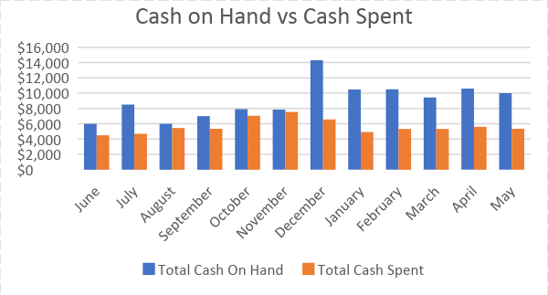
Once you have a clear understanding of the pattern, or seasonality, of your income and expenses, you are ready to dive into your current sales and expenses and project them forward. This includes documenting the income from current sales, predicting (yes, that is guessing) at new business based on your marketing plan and market growth, and forecasting your expenses based on rent increases, raises for staff, new equipment buys, and your increasing cost of goods sold as your sales increase. This will be frustrating at first, but remember – the only thing we know about every forecast in the world is that they are wrong. We are not trying to be perfect, we are trying to manage to the best of our ability.
To begin forecasting your cash flow, follow these steps:
- Enter the next twelve periods into your cash flow statement (i.e. add the next twelve months in new columns)
- For every line, both income and expense, invest time guessing what you will make or spend across each month – be sure take into account both the historical figures AND what you know is going to happen (i.e. big marketing campaign, new product line, new market/region, etc.)
  - Yes, guessing is OK. We will get better over time and have to start somewhere. Relax knowing there is no one else in the world that knows your business as well as you do. Your guess is the best forecast possible and will get better the more you do it.
- Once numbers are in every row and month, make them a graph and see if the pattern changes dramatically – if so, make sure that is what you truly expect to happen.
Our ability will improve over time, but it is going to take watching the P&L and Cash Flow statements over time and really exploring what we overlooked in our forecast when it was very inaccurate. One example is a family run business had gotten very good at predicting sales and established quarterly partnerships with local events that really boosted their sales. Until one quarter a hurricane pushed nine inches of rain into the region on the Saturday and Sunday of the event. The managers were planning for their largest sale weekend in history, but ignored the incoming weather. It took deep discounts to work through their inventory and still had thousands in spoilage. As we plan our cash flow, please consider everything that you know impacts your business. Make wise decisions before committing to large expenses and work hard to manage how long it takes to receive payment for your investment.
Work hard to reduce your payment cycle (or cash to cash cycle). Some firms are lucky enough to receive payment before they even buy their inputs for their product. However, most of us have to invest up front and work hard to create a return on that investment. Working with your suppliers to negotiate good terms is critical. This includes building a relationship with your wholesaler to buy on credit (i.e. getting billed at the end of the month), or even offering discounts for prompt payment. Be creative in how you can bring your return on investment closer to the time you spend your own cash. And remember the cash flow tool you create in the spreadsheet allows you to enter the forecasted amounts in and see how your change in payment terms or discounts for prompt payment impact your cash flow.
Finally, a short note on helping bridge the cash flow gaps you may have when growing quickly. Sometimes you will need to invest heavily in a project/inventory and require a loan to prepare for growth. In these times you will need someone to provide you the cash required. There are many resources for this, but you have to keep in mind that each one comes with strings. Even a family loan brings with it interest and stress that have to be considered. Traditionally, the way companies fund this growth are through bank loans. Regardless of how you procure you cash, please think of it is just one more type of inventory.
That is right, your cash is just like the products on the shelf, the paper under the printer and the fuel in your tank. It is provided by a supplier, often a bank, and the relationship with that supplier should be developed and cultivated over time. Remember, the bank wants to lend you money. That is how they make money. If you have met with them quarterly for years and talked them through your growth plan and success, they are much more likely to understand your P&L and cash flow statements when you come in for a loan. And by being able to project your sales and control your expenses with an understandable plan, you reduce their risk in lending you money and it becomes a win-win relationship. This holds true for banks, the microloan providers, and even family investors.
RESOURCES & TIPS: to help manage long payment cycles
- SBA microloans can be used to bridge accounts receivables in many cases (https://www.sba.gov/funding-programs/loans)
- Your Local Bank - often banks run low interest bridge loans for small businesses based on receivables if you develop a strong relationship with the bank BEFORE you need the bridge, they are more likely to score you at a lower risk and provide the loan. Work to build that relationship before you need it!
- Try not to use credit cards or any other high interest methods to bridge payment gaps, as high interest rates are incredibly harmful if not used responsibly.

